Section 1 PREVENTIVE MAINTENANCE OF UILLEANN PIPES
The Piper Must Take Responsibility
If you wish to achieve a good standard of piping; from the moment you take possession of your set of pipes, you must ensure that they are maintained in the best possible playable condition. This will mean:
- Becoming familiar with all of the parts of the instrument
- Acquiring the necessary items such as hemp, wax, point-nosed pliers and similar gadgets.
- Gaining the experience to be able to undertake the various tasks which arise from time to time
- Developing the discernment to know the tasks which the piper may safely carry out and what needs to be left to the professional pipe maker to rectify or repair.
Checking and Renewing the Bindings
Apart from the various reeds, the pipes have various adjustable and moving parts:
- drone slides which are adjusted when the pipes are tuned and re-tuned and
- The chanter top which is adjusted to suit the player’s hand hold.
The various ornamental mounts especially those on the ends of the drones and regulators all require effective hemping.
Additionally, the regulators and top sections of the drones which are set within the main stock need to be maintained in place by hemp or other adequate and appropriate thread bindings.
These bindings must be kept in good condition and held secure, neither too tight nor too loose for the particular function.
DO NOT USE PLUMBERS’ PTFE TAPE AS IT LACKS THE APPROPRIATE GRIP CAPABILITY AND DOES NOT EFFECTIVELY SECURE THE COMPONENT IN POSITION AND IS A NUISANCE TO ATTEMPT TO REMOVE. Hemp thread functions best but has to be appropriate for the particular function. To secure it in place it is best that it be waxed for the initial strands which are tied onto the wood. On the outward portion of the binding, the hemp can be unwaxed such as for example to ensure that a drone slide portion effectively slides on the top end of the when the tuning adjustment is being made.
Any part of the turned wood to be hemped should be properly “combed” that is with lines formed in the drone or regulator at say 1 mm intervals along the piece to help the hemp to stay in place.

NOTE PARTICULARLY
THE CHANTER TOP The top enclosing the reed must be neither too tight or too loose. It must facilitate adjustment so that the tone holes are appropriately positioned in relation to the hands, sometimes this may vary slightly. When adjusting the position of the chanter top, ALWAYS GRASP THE CHANTER NEXT TO THE CHANTER TOP. grasping the chanter low down and twisting it within could cause it to snap off at the thinnest part, at the back D hole where also the wood of the chanter is at its thinnest and weakest. Twisting the chanter very tightly bound into the top could cause this to happen.
DRONE SLIDE BINDINGS These must be renewed from time to time by the player to avoid accidents such as a drone slide falling off and causing a mount to break or chip off upon hitting a hard floor surface.
Drone top-sections must be securely set in place within the main stock;
(a) Not so tight as to be excessively difficult to remove
(b) Not so loose as to be capable of moving laterally within the stock and causing the guill to touch the sides of the bore hole in the stock but
(c) firmly enough so as not to be drawn out from the stock when the drone slide is adjusted higher or lower depending on whether the drone is significantly sharpened or flattened.
NOTE ALSO If a drone tunes out very far on its slide it may be in danger of falling off and on to the floor and becoming damaged.
REGULATORS These must also be securely set within the main stock. They must also be securely bound in place,
- tight enough so as not to fall out accidentally but free enough to enable them to be taken out to adjust the regulator reed if necessary and
- To allow individual regulators to be moved slightly laterally to have for example the keys of the tenor and middle regulators to point towards each other or perhaps middle and bass regulator slightly pointing away from each other.
SEE FIGURE 1 & 1 (a ) for examples of the above points
CHECKING GENERAL AIR-TIGHTNESS OF BELLOWS AND BAG
Bindings maintenance and valves maintenance in these locations is vital to verifying that the set is in good playing condition. Testing a set of pipes to see if there is any traces of air leakage should always be done sequentially, commencing at the bellows.
SEE FIGURES 2 and 3 for examples of the above points
Testing the bellows is done to see whether there is any leak from either the valve in the event of it not functioning properly, allowing back flow of air back through the valve or in case of the valve hole not being bored cleanly through the wood. It is possible that the binding of the valve might not prevent air leakage out of tiny gaps between valve bindings and the wood of the bellows board if there are any roughnesses in the hole of the bellows board.
In the case of the blowpipe connected to the bag blow pipe, it is necessary to ensure that the connecting binding is also airtight.
REMEMBER TO CHECK THAT THE HINGES OF THE BELLOWS AND THE BAG BLOWPIPE VALVE ARE ALWAYS AT THE TOP WHEN THE PIPES ARE IN THE PLAYING POSITION.
Sometimes the bag valve can sound noisy and a little application of olive oil or even a slight smear of Vaseline petroleum jelly on the leather face which closes against the wood or imitation ivory surface of bellows or bag valve will cure this and reduce the refluxing tendencies also.
SEE FIGURE 4 (a) for illustrations of the above points
Places to watch for when seeking out possible bellows leaks are:
- The leather folds which over time may have become porous due to repeated folding and opening.
- The location of the bellows leather underneath the hinged area. If the leather is insufficiently glued or stitched, air may leak from underneath the hinge.
- It is possible also that leaking might occur from the tacked or stapled or stitched area.
- If the blowpipe outlet from the bellows board is not properly caulked or sealed such as with araldite type glue ( where the outlet is secured on the inside of the bellows board) or secured by a flange connector a leak can occur here also.
- It is also possible that screws securing the brackets for the straps for arm or waist may be driven into the bellows board too far and may penetrate the wood through the full thickness. This may be a problem where the wood of the bellows board is thin or the screw too long. Significant leaking can be caused by this oversight in the making of a bellows.
SEE FIGURE 4 for examples of the above points
A PARTICULAR BELLOWS PROBLEM WHICH CAN EASILY BE RECTIFIED BY THE MAKER
The bellows valve mount is sometimes drilled out to admit air around the sides only. This has been done so that when the piper’s coat or jacket sleeve fall over the valve, the air will still be admitted around the valve holes around the sides. However if these holes around the sides are small, lack of air intake space can cause a resistance to the opening stroke of the bellows. To avoid increased resistance when air is being drawn in, and an unnecessary “fwhoosh” noise problem being created because of the unnecessarily limited air intake through the valve, the centre of the valve should be bored out by the pipemaker. This solves the problem and improves the bellows performance.
SEE ALSO FIGURE 4 for the above point
CHECKING GENERAL AIR-TIGHTNESS OF THE BAG AND THE BODY OF THE INSTRUMENT
When the bellows has been found to be fully air-tight, the body of the instrument can then similarly be checked as follows:
Fill up the bag with air with the chanter removed and the end of the neck stopped with the finger.
Ensure that the drone switch is also shut off. When the bellows and bag are put under playing pressure to see whether there is any loss of air, there should be no air escape; the bag should not deflate under pressure and there should be no leaks from the body of the pipes.
If there is a suspicion of leaks anywhere in the instrument these must be systematically located and corrected.
Possible air leak locations in the body of a full set of pipes
Chanter:
- The chanter reed needs to be set securely in place, properly hemped in.
- Chanter keys in a set in use for some time need to be checked to see that key pads are not a source of leaks. A spring may become weak or a key may develop excessive play and fail to return properly on the note hole flat area.
- A mount on the chanter top may require re-hemping as it may also leak air under pressure and similarly a chanter stop key may also leak air.
- Key leak problems may require to be done by a professional pipe maker.

Bag:
- Stitching or glued joints. Generally the best solution for the amateur is to have the bag replaced.
- Tying of stocks. Occasionally a stock may gradually work loose especially if the tying of the stock was unsatisfactory. These weakened tyings gradually develop into air leaks which require either secure re-tying or a new bag fitted.
When stocks are being tied in the best sequence to follow is:
( a ) Tie the bag neck stock and then check for air-tightness
(b) Tie the blow pipe stock and then check for air-tightness with the stocks corked or bunged-up
(c) Main stock and cup.
With three stocks corked or bunged-up the bag can then be checked for air-tightness.
Under these conditions, the bag when inflated should remain taut without any loss of air. Blow pipe valve should be checked to ensure that it is not allowing and back flow of air under pressure.

Then with the bellows and bag found to be air-tight the body of the set can be systematically checked to see if any air leakage is occurring.
FIGURE 5 showing the start of this process
Possible sources of air leaking from the body are.
- Drone or regulator reeds, if these are not properly hemp bound into their respective reed beds.
- Main stock where hemp is bound into the main stock cup. This binding should be secure but still allowing slight movement in case it is required to adjust the position of the stock to allow the regulator keys to be manipulated in a certain way.
- Bass regulator straddle, where connected to the main stock. It is possible that the leather gasket under the straddle, may be leaking a little. Tightening the screws may help. It is preferable to leave this to a professional pipe maker as the slots may become damaged by an in-experienced amateur attempting to tighten a screw driven into hardwood, without the most suitable screw driver. The straddle may become loose if the shoulder strap is only tied around the straddle. THIS STRAP SHOULD ALWAYS BE TIED AROUND AND STRUNG FROM THE MAINSTOCK. See figure 7. It is also possible that in the case of a flat set of pipes, that a hollow stock may be cracked. The wall of a hollow wooden stock is very thin and cracking may develop over time.
- Drone assembly components, especially those of the bass drone. These need to be checked individually in sections, blowing by mouth if necessary to check for leaks
- Individual regulators. End mounts, tuning pins and keys need to be checked to see that they are not leaking. BLOW INTO THE REGULATOR TO SEE IF AIR IS LEAKING OUT UNDER PRESSURE. SEE FIGURE 6 Individual regulator keys need to be checked to see if any key pads is leaking. A spring may become weak or the key may have excessive play and fail to return properly on the note hole flat area. Rectifying leaky regulator keys should be left to the professional pipe maker.
- The cap or the mount on the cap of the bass regulator may require attention such as re-hemping of both the cap mount or even the area where the cap fits on the bar, enclosing the bass regulator reed. Similarly the keyed section of the regulator where hemped into the bass bar/top section could leak if the binding becomes frayed.

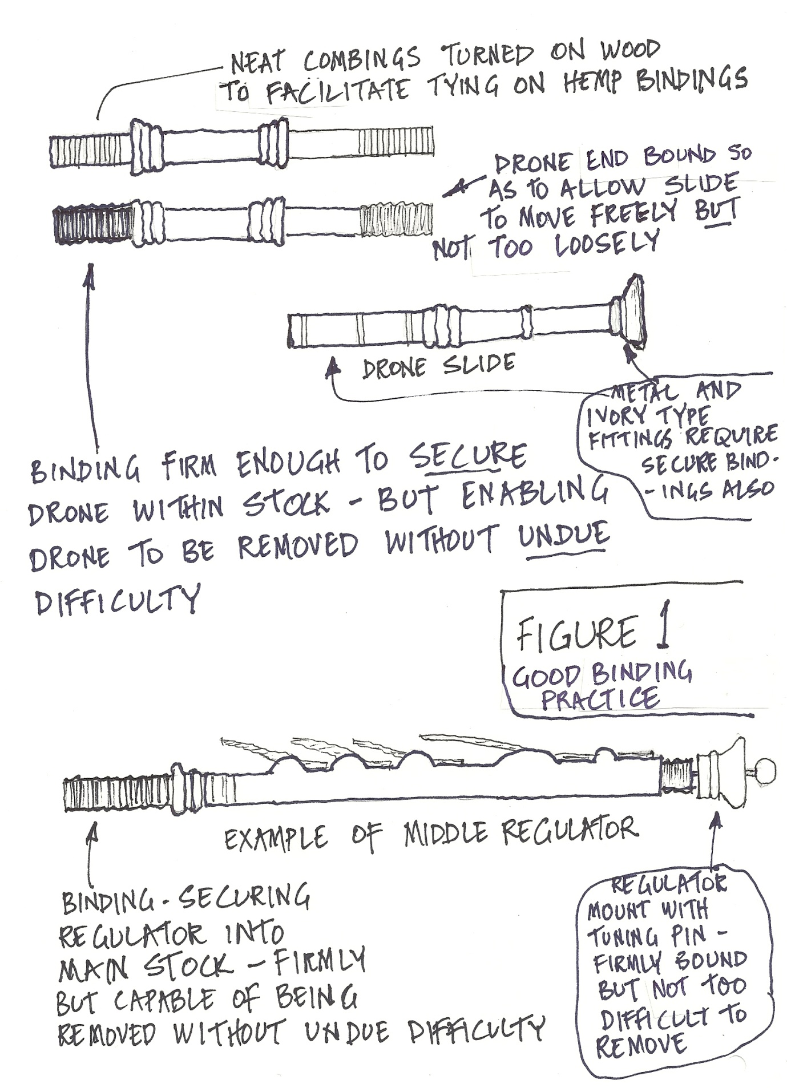

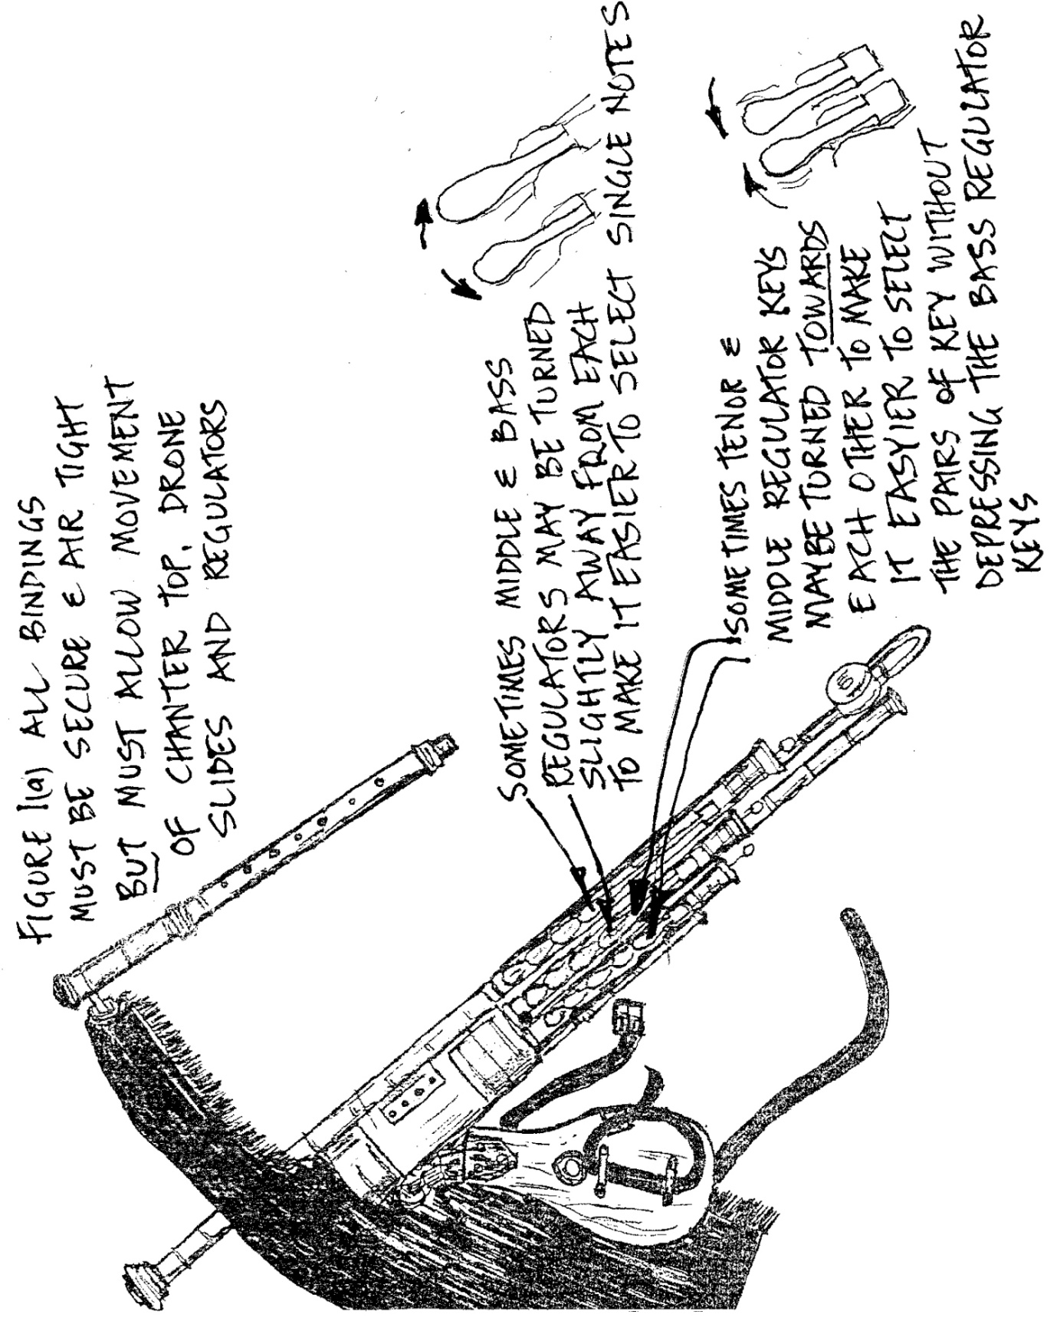
FIGURE 1 (a) Chanter must be securely hemped in place, drones and regulators must be securely bound in place set within the main stock.

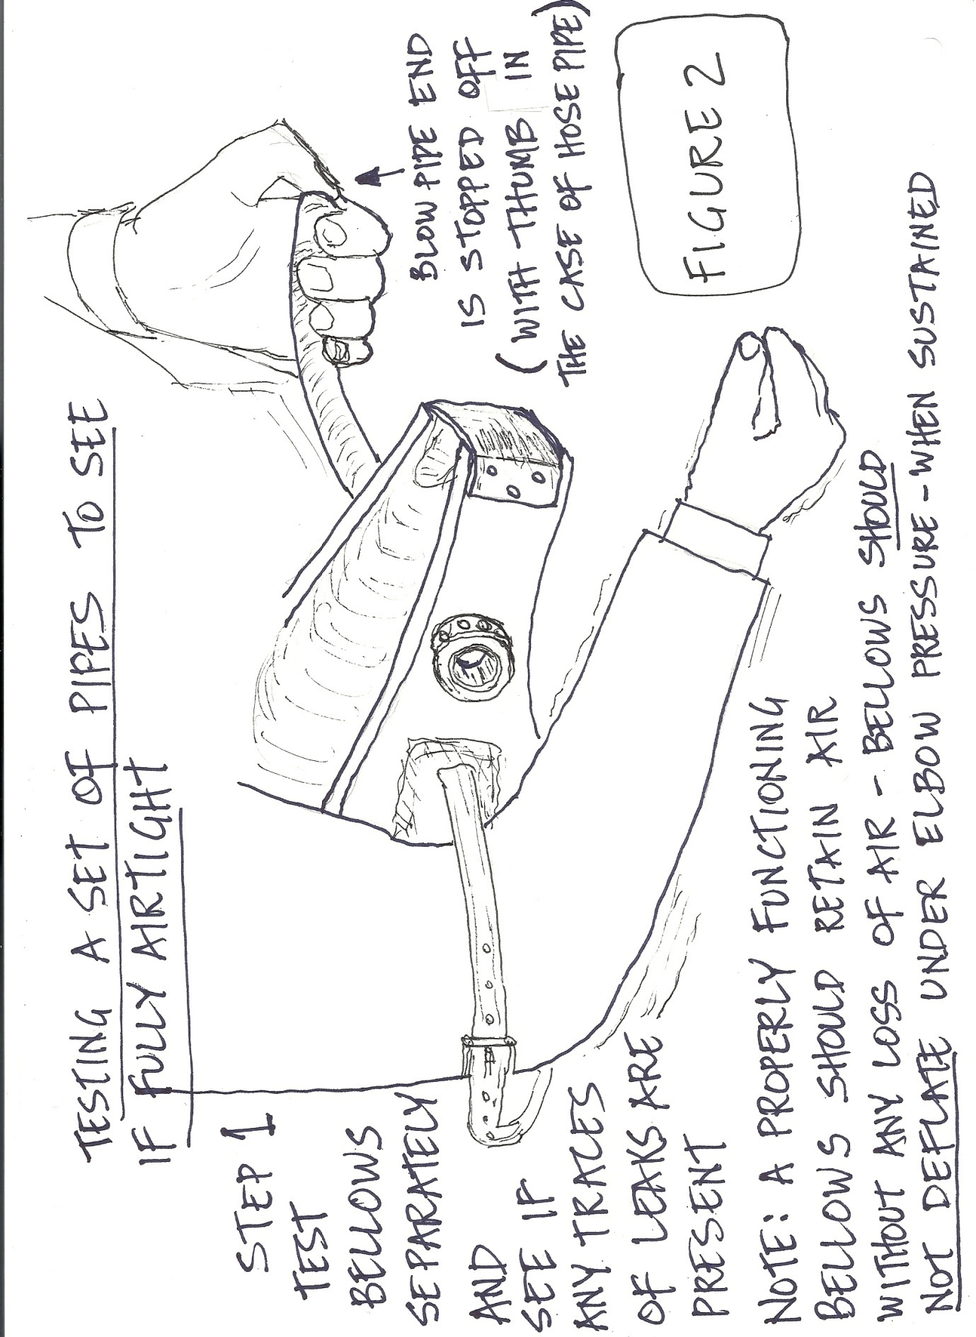

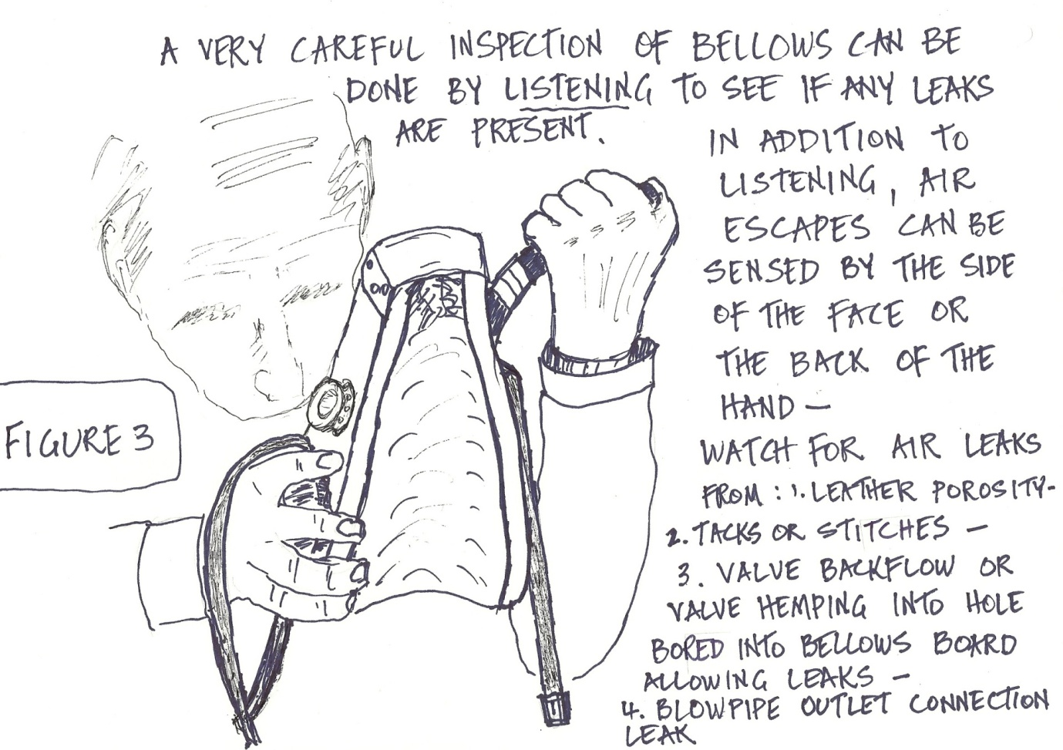

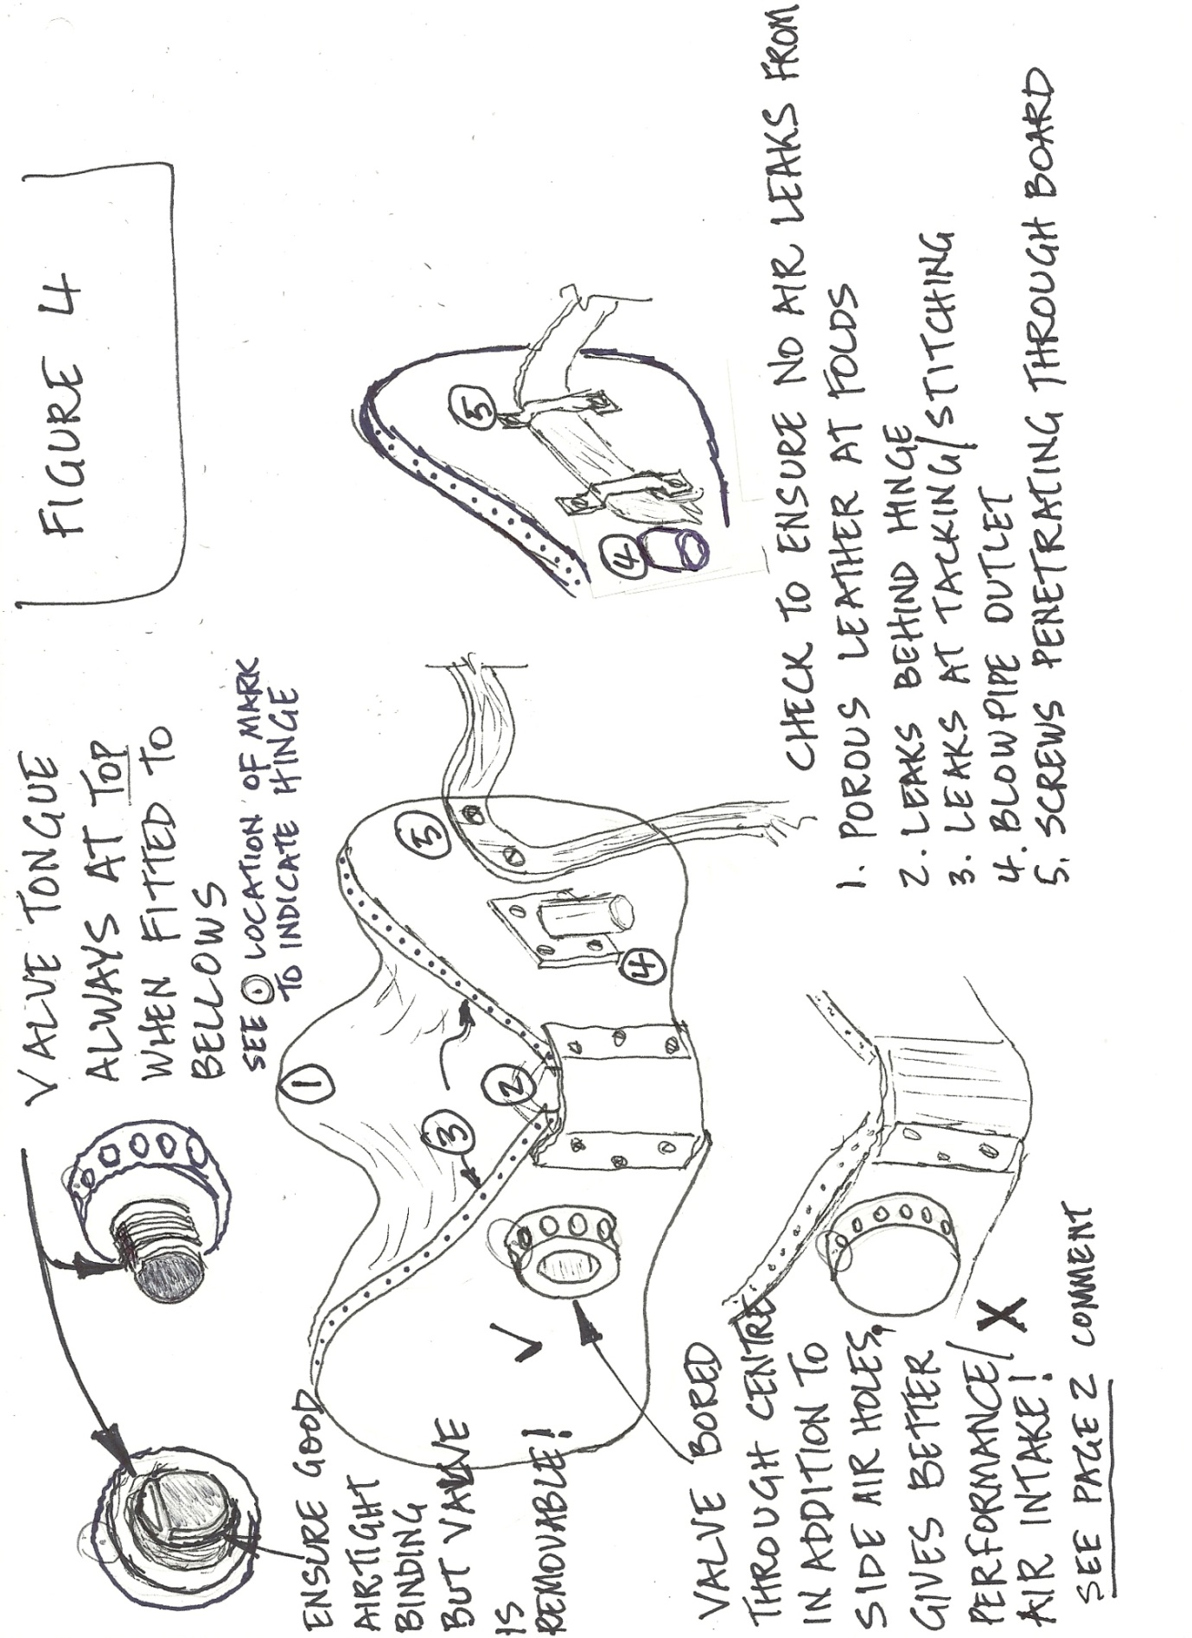

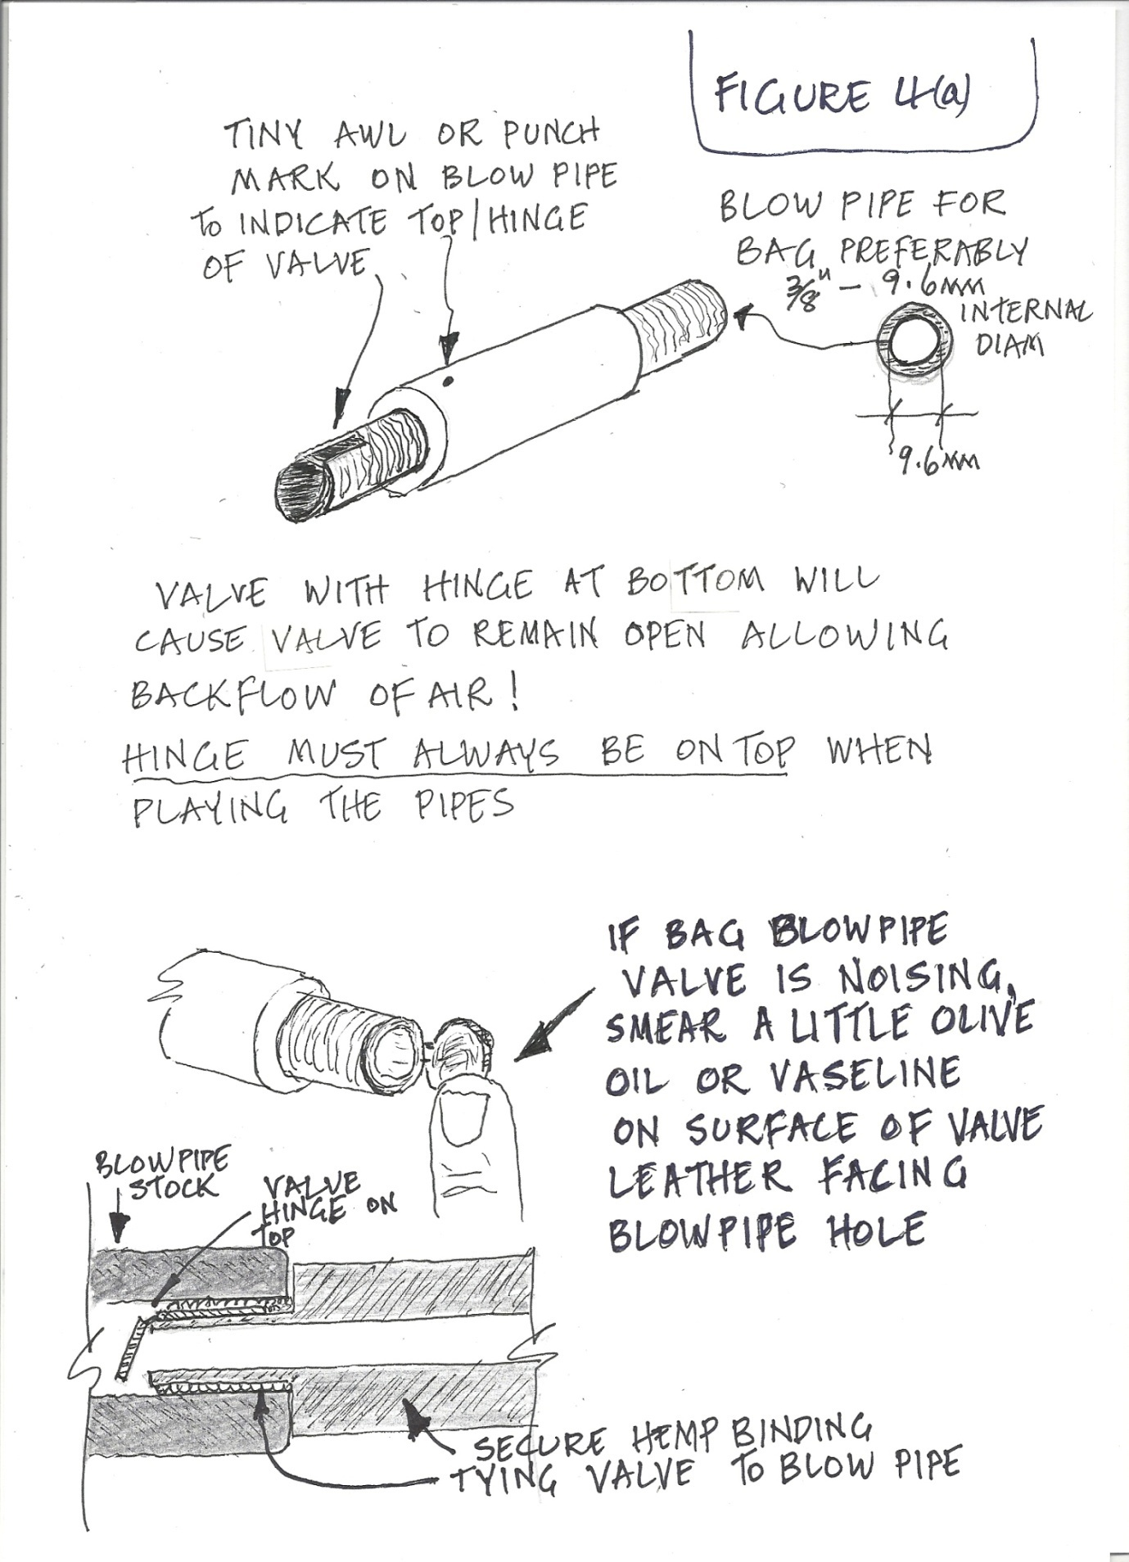

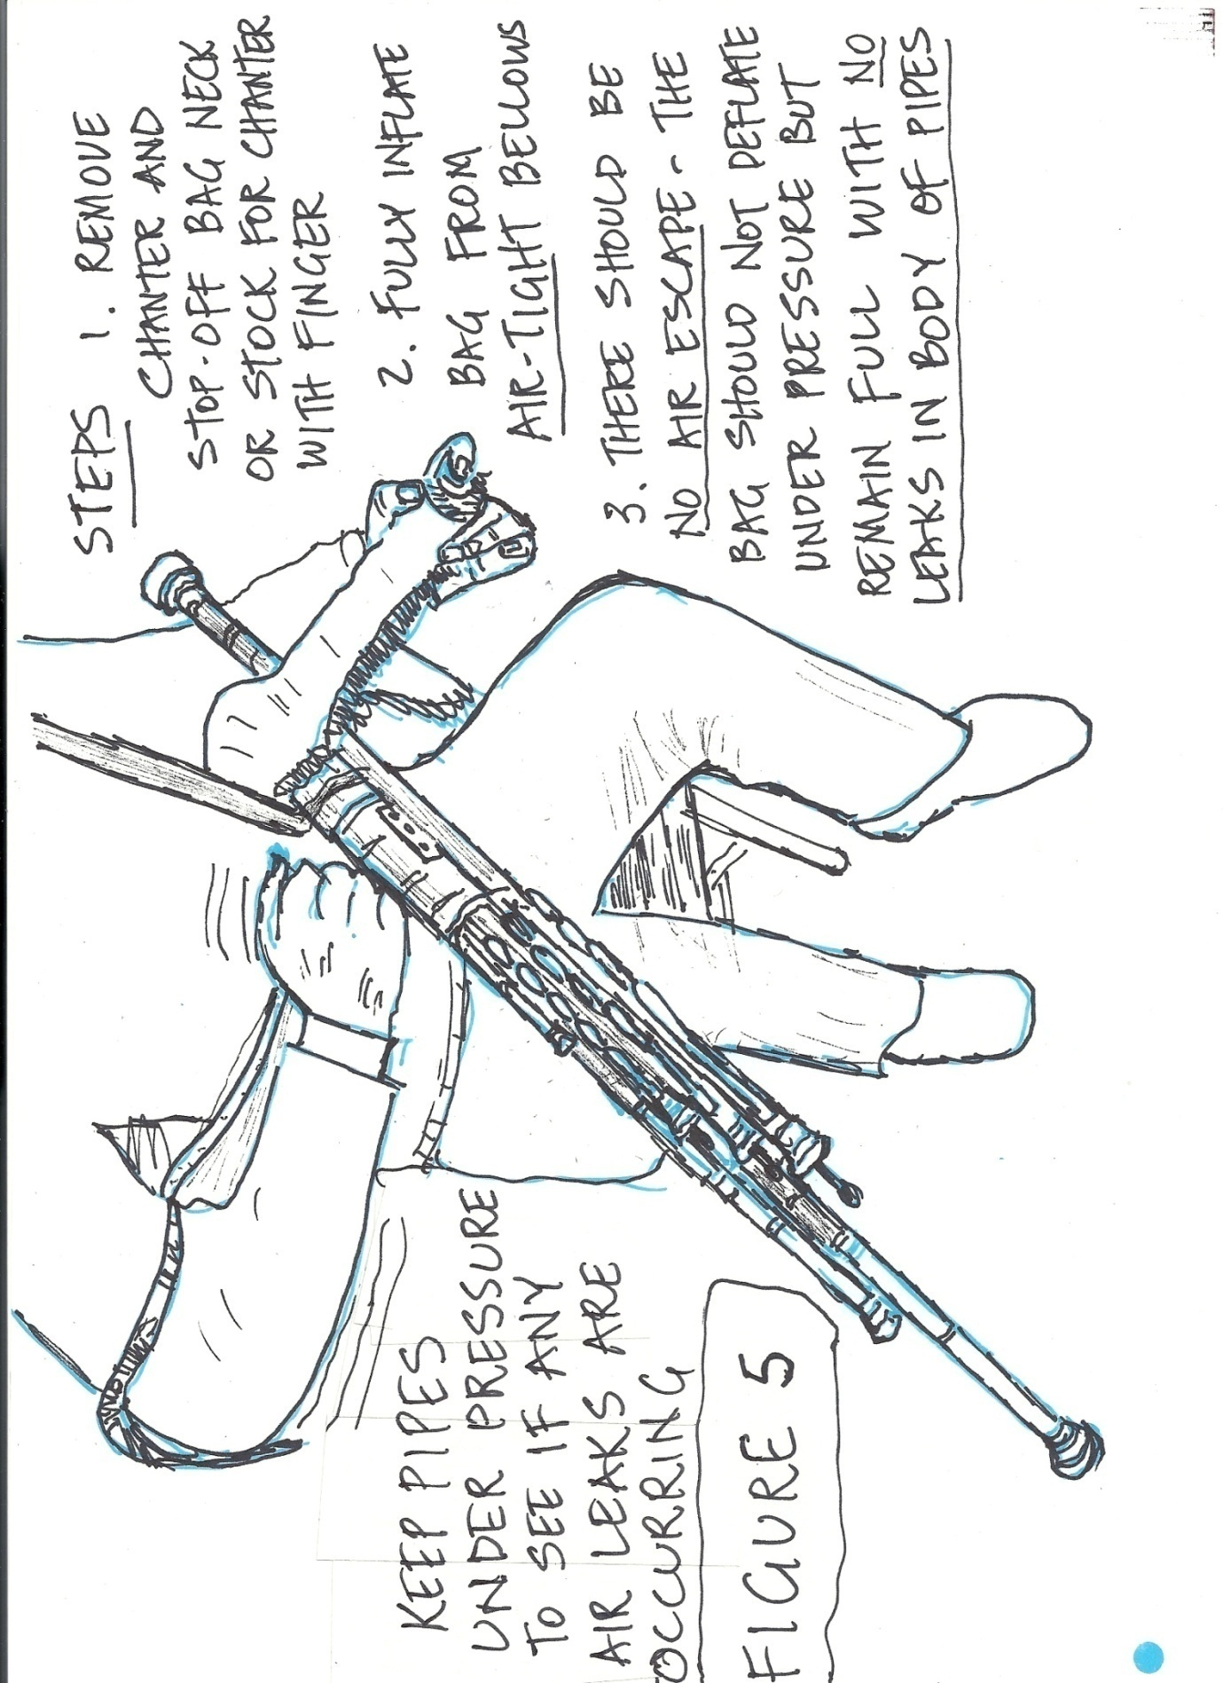

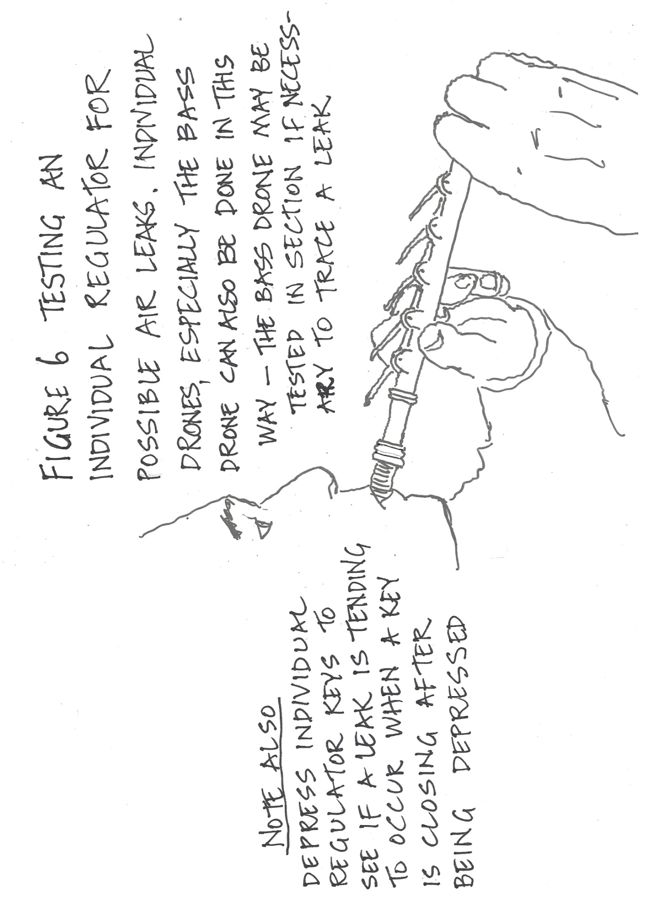
BLOW INTO THE REGULATOR TO SEE IF AIR IS LEAKING OUT UNDER PRESSURE
